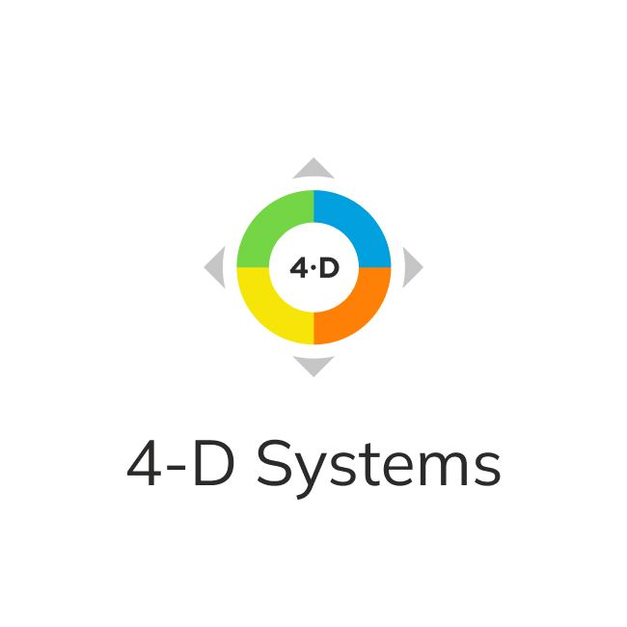

Team Development Assessment (TDA)
By Charles J. Pellerin

A QUICK GUIDE

Commitment to your confidentiality
4-D Systems representatives, authorized by Charles J. Pellerin, will not provide any data in the TDA report to anyone but you and/or those who are officially authorized by you to do so.

TDA request form (Team Development Assessment)
Your Team Development Assessment process has the following stages:
- The requirements for team members are as follows: working together in a team/project for at least 3 months, maximum number should not exceed 20 people. If there are more people in a team, they should be divided into groups of up to 20 people.
- Fill out the IDA application form at least 7 days before the assessment and email it to galarich@me.com. In the application, please indicate: country, city, company name, IDA dates, name and surname and email of the contact person
- After receiving the application we will contact you and discuss payment terms.
- After the payment, a TDA link will be sent to the e-mail address you provided.
- Send the link to all your TDA participants.
- After completing TDA you will receive the generated team report in 4 working days in PDF format. The report processing time is valid for one team of up to 20 people

Expert support
Galina Nagovitsyna officially authorized by Charles Pellerin to train and certify 4-D consultants/trainers/providers ; 4-D Consultant/Business Coach PCC ICF Coach galarich@me.com
Olga Mityushkina, 4-D Systems Project Manager, 4-D Consultant/Business Coach, PCC ICF Coach olqa.mityushkina@gmail.com

The Eight Assessed Behaviors
- Expressing Authentic Appreciation
- Addressing Shared Interests
- Appropriately Including Others
- Keeping All Your Agreements
- Expressing Reality-based Optimism
- Being 100% Outcome Committed
- Resisting Blaming or Complaining
- Clarifying Roles, Accountability and Authority (RAAs)

