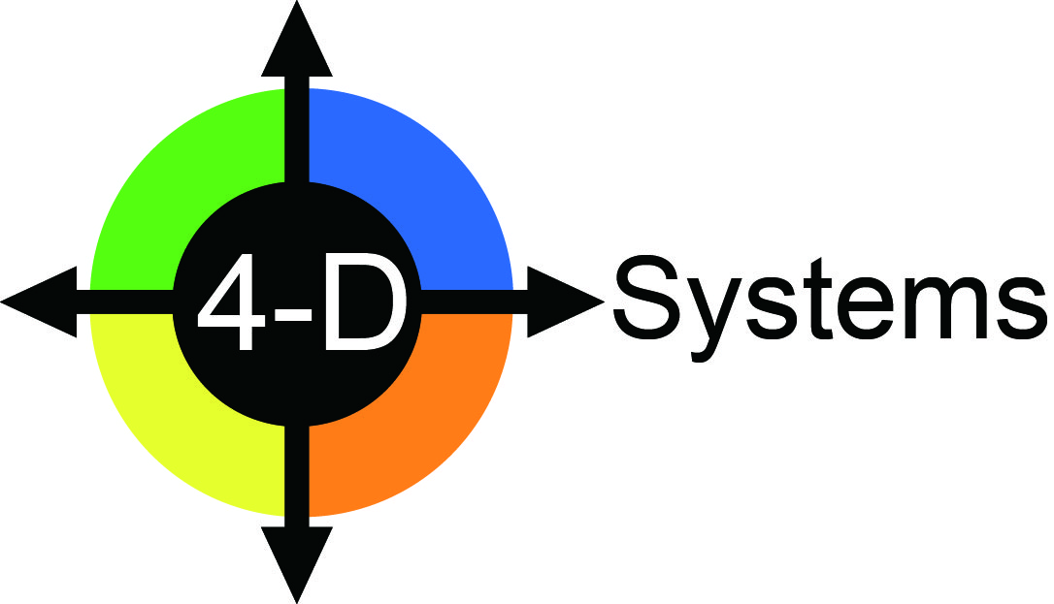

Authorization

I, Charles J. Pellerin, Jr., authorize Galina Nagovitsyna to practice and apply the full 4-D System (Workshops, on-line Assessments/Accelerators, and Coaching/Consulting with the Context Shifting Worksheet (CSW)) as she has demonstrated Mastery of these processes.

Furthermore, I authorize Galina Nagovitsyna to grant certificates to participants who successfully complete her “4-D System” program to practice and apply the full package of 4-D System processes and materials.



Charles J. Pellerin, Jr. PhD

President, 4-D Systems